40.56: a) As with the particle in a box,
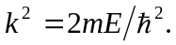 Unlike the particle in a box, however, and hence do not have simple forms. b) For 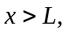 the wave function must have the form of Eq. (40.18). For the wave function to remain finite as as in
Eq. (14.17) and Eq. (40.18). c) At Dividing the second of these by the first gives
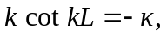
a transcendental equation that must be solved numerically for different values of the length and the ratio 